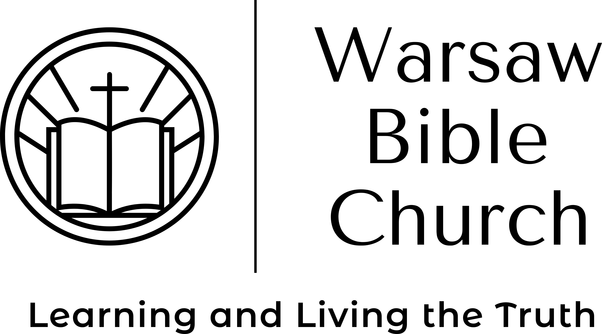 |  |  |  | How To Read the Bible  Pastor Jason McCray

Why should I read the Bible?
The Bible is necessary for Christians as part of their ‘spiritual sustenance’ in order to grow up in salvation (1 Peter 2:2), to grow deeper in faith (Romans 10:17), to discern their heart (Hebrews 4:12) and to know God better and be blessed (Revelation 1:3).

Before you read the Bible…pray.
Since the Bible is a supernatural book, it is needful to ask the Author for help in understanding His book.

How should I read the Bible?
Read entire books and sections, not isolated verses. This will keep you from taking things out of context.

Where should I start?
Start by reading Genesis, which tells the history of creation, of sin and of God calling a certain group of people to be His chosen nation.

Then read Luke, Acts and then Romans. That way you will learn about Jesus, about the church and about yourself.

After that, it will depend upon what you want to learn. If you want to learn about Jesus then read the gospels. If you want to learn about your position in Christ, then Ephesians. If about joy and rejoicing, then Philippians. If about practical daily wisdom, then James and Proverbs. If about whether you are saved or not, then 1 John.

Helpful Hints
Reduce distractions. Read when you are alert. Use a reading plan (google it). Have an accountability partner to challenge yourself. If you have trouble reading, then supplement your reading with an audio bible.

16155 Waggoner Rd
Warsaw, MO 65355
 |  | 660-723-3719
 |  | pastorjmccray@gmail.com
 |  | Warsawbiblechurch.org

